Spherical Cap
# Source: AI Source: Provided by: [Data Path: Persons Table -> ID Column: 1, Name_En Column: Motasem Essam] -> From: [ChatGPT] on [7/25/2026]
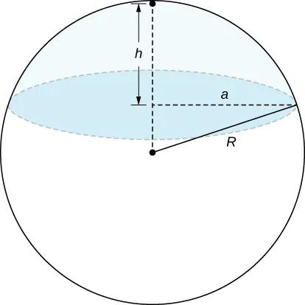
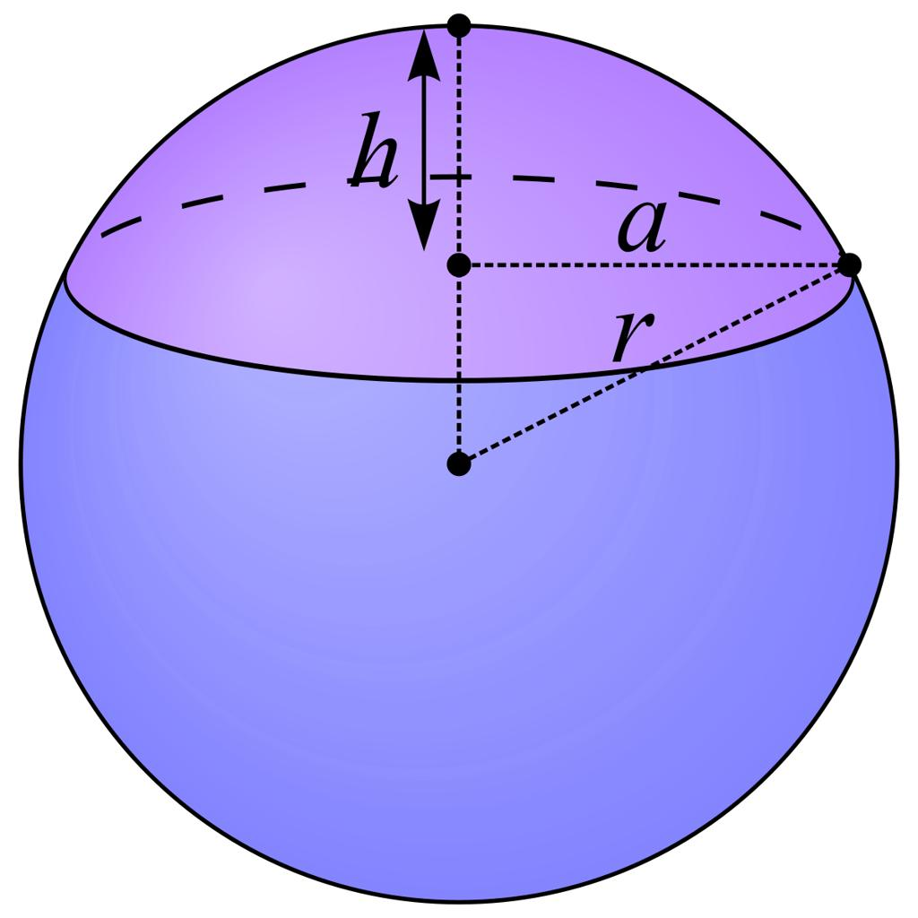
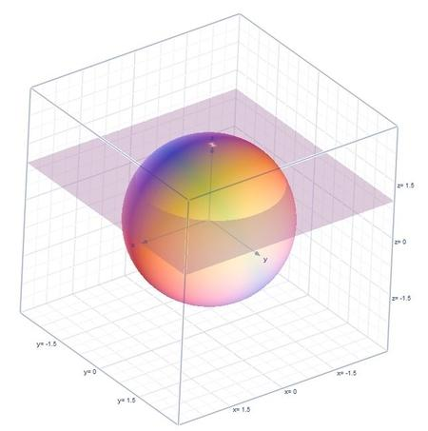
7

Definition
# Source: AI Source: Provided by: [Data Path: Persons Table -> ID Column: 1, Name_En Column: Motasem Essam] -> From: [ChatGPT] on [7/25/2026]
A spherical cap is the portion of a solid sphere separated from the rest of the sphere by a plane. It consists of the curved spherical surface and the solid region enclosed by that surface and the circular base formed by the cutting plane.
A spherical cap is formed when a plane cuts through a sphere without necessarily passing through its center.

Simple Definition
# Source: AI Source: Provided by: [Data Path: Persons Table -> ID Column: 1, Name_En Column: Motasem Essam] -> From: [ChatGPT] on [7/25/2026]
A spherical cap is a dome-shaped part of a sphere cut off by a flat plane.
Examples include the dome of a spherical structure, the rounded top of some containers, and the cap-shaped portion of a ball.

Types of Spherical Caps
# Source: AI Source: Provided by: [Data Path: Persons Table -> ID Column: 1, Name_En Column: Motasem Essam] -> From: [ChatGPT] on [7/25/2026]
Spherical caps can be classified according to their size and position.

1. Minor Spherical Cap
# Source: AI Source: Provided by: [Data Path: Persons Table -> ID Column: 1, Name_En Column: Motasem Essam] -> From: [ChatGPT] on [7/25/2026]
A cap whose height is less than the radius of the sphere. It is smaller than a hemisphere.
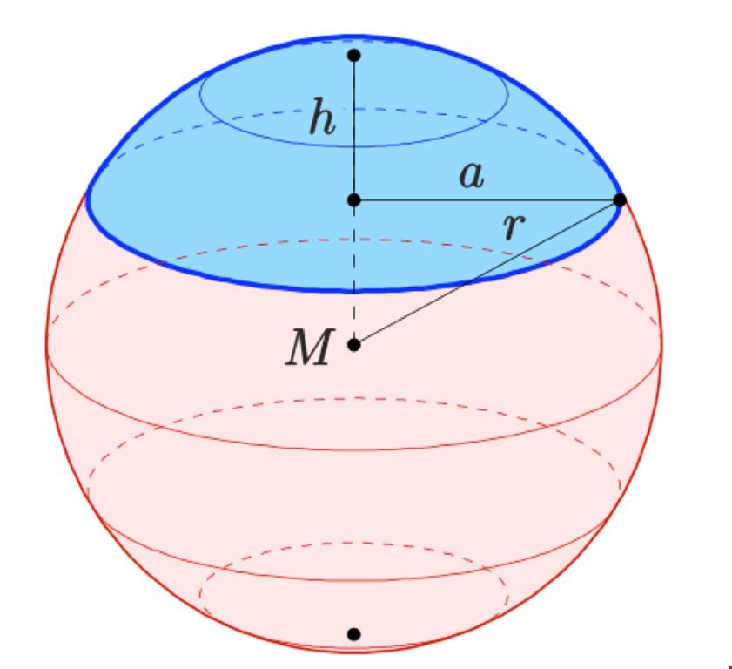

2. Hemispherical Cap
# Source: AI Source: Provided by: [Data Path: Persons Table -> ID Column: 1, Name_En Column: Motasem Essam] -> From: [ChatGPT] on [7/25/2026]
A cap formed by cutting the sphere through its center. Its height equals the sphere radius, and the cap is a hemisphere.

3. Major Spherical Cap
# Source: AI Source: Provided by: [Data Path: Persons Table -> ID Column: 1, Name_En Column: Motasem Essam] -> From: [ChatGPT] on [7/25/2026]
A cap whose height exceeds the sphere radius. It contains more than half of the sphere's volume.
These are descriptive classifications based on cap height. The minor and major caps are not different kinds of sphere; they are different-sized portions of the same sphere.
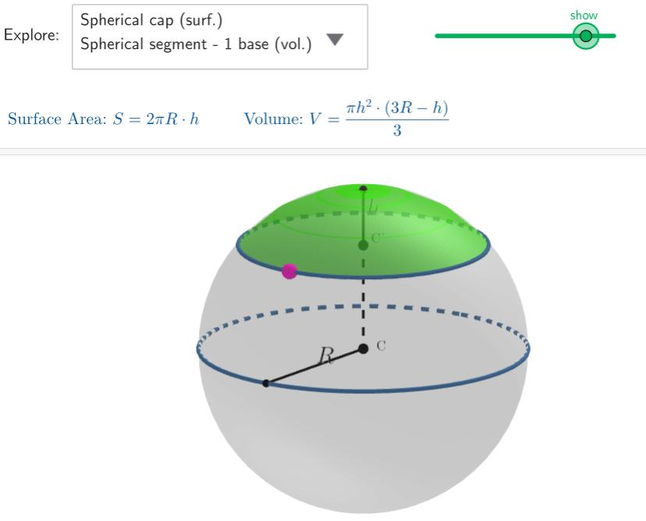

Main Parts and Symbols
# Source: AI Source: Provided by: [Data Path: Persons Table -> ID Column: 1, Name_En Column: Motasem Essam] -> From: [ChatGPT] on [7/25/2026]
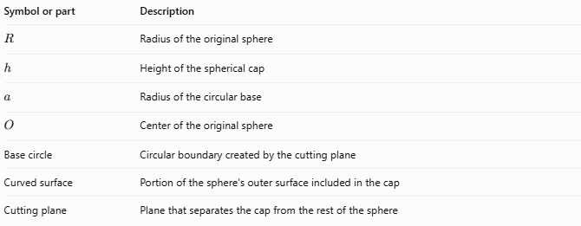
Symbol or part | Description
$$R$$ | Radius of the original sphere
$$h$$ | Height of the spherical cap
$$a$$ | Radius of the circular base
$$O$$ | Center of the original sphere
Base circle | Circular boundary created by the cutting plane
Curved surface | Portion of the sphere's outer surface included in the cap
Cutting plane | Plane that separates the cap from the rest of the sphere
The cap height $h$ is measured perpendicular to the base plane, from the base to the top of the cap.

Mathematical Formulas
# Source: AI Source: Provided by: [Data Path: Persons Table -> ID Column: 1, Name_En Column: Motasem Essam] -> From: [ChatGPT] on [7/25/2026]
Let $R$ be the sphere radius, $h$ the cap height, and $a$ the base radius.

A. Radius of the Base Circle
# Source: AI Source: Provided by: [Data Path: Persons Table -> ID Column: 1, Name_En Column: Motasem Essam] -> From: [ChatGPT] on [7/25/2026]
Using the right triangle formed by the sphere center, the base-circle center, and a point on the base circle:
$$a^{2}=R^{2}-{\left(R-h\right)}^{2}$$
Expanding and simplifying:
$$\boxed{a=\sqrt{2Rh-h^{2}}}$$
This formula applies for $0≤h≤2R$.

B. Curved Surface Area
# Source: AI Source: Provided by: [Data Path: Persons Table -> ID Column: 1, Name_En Column: Motasem Essam] -> From: [ChatGPT] on [7/25/2026]
The area of the curved spherical surface of the cap is:
$$\boxed{A_{c}=2πRh}$$

C. Volume
# Source: AI Source: Provided by: [Data Path: Persons Table -> ID Column: 1, Name_En Column: Motasem Essam] -> From: [ChatGPT] on [7/25/2026]
The volume enclosed by the spherical cap is:
$$\boxed{V=\frac{πh^{2}}{3}\left(3R-h\right)}$$

D. Total Surface Area
# Source: AI Source: Provided by: [Data Path: Persons Table -> ID Column: 1, Name_En Column: Motasem Essam] -> From: [ChatGPT] on [7/25/2026]
If the flat circular base is included, the total surface area is:
$$A_{T}=2πRh+πa^{2}$$
Substituting $a^{2}=2Rh-h^{2}$:
$$\boxed{A_{T}=π\left(2Rh+2Rh-h^{2}\right)}$$
Therefore,
$$\boxed{A_{T}=πh\left(4R-h\right)}$$
This total includes both the curved surface and the flat base.

Worked Examples
# Source: AI Source: Provided by: [Data Path: Persons Table -> ID Column: 1, Name_En Column: Motasem Essam] -> From: [ChatGPT] on [7/25/2026]
Example 1: Finding the Base Radius
A spherical cap has sphere radius $R=10\text{ cm}$ and height $h=4\text{ cm}$. Find its base radius.
Solution
$$a=\sqrt{2Rh-h^{2}}$$
Substitute the values:
$$a=\sqrt{2\left(10\right)\left(4\right)-4^{2}}$$
$$a=\sqrt{80-16}=\sqrt{64}$$
$$\boxed{a=8\text{ cm}}$$
Example 2: Finding the Curved Surface Area
A spherical cap has $R=7\text{ cm}$ and $h=3\text{ cm}$. Find its curved surface area.
$$A_{c}=2πRh$$
$$A_{c}=2π\left(7\right)\left(3\right)$$
$$\boxed{A_{c}=42π{\text{ cm}}^{2}≈131.95{\text{ cm}}^{2}}$$
Example 3: Finding the Volume
A spherical cap has $R=6\text{ cm}$ and $h=2\text{ cm}$. Find its volume.
$$V=\frac{πh^{2}}{3}\left(3R-h\right)$$
$$V=\frac{π{\left(2\right)}^{2}}{3}\left(3\left(6\right)-2\right)$$
$$V=\frac{4π}{3}\left(16\right)$$
$$\boxed{V=\frac{64π}{3}{\text{ cm}}^{3}≈67.02{\text{ cm}}^{3}}$$
Example 4: Finding the Total Surface Area
A spherical cap has $R=5\text{ cm}$ and $h=2\text{ cm}$.
$$A_{T}=πh\left(4R-h\right)$$
$$A_{T}=π\left(2\right)\left(20-2\right)$$
$$\boxed{A_{T}=36π{\text{ cm}}^{2}≈113.10{\text{ cm}}^{2}}$$

Comparison with Related Geometric Shapes
# Source: AI Source: Provided by: [Data Path: Persons Table -> ID Column: 1, Name_En Column: Motasem Essam] -> From: [ChatGPT] on [7/25/2026]
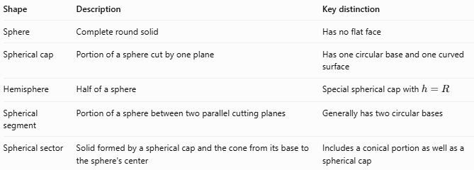
Shape | Description | Key distinction
Sphere | Complete round solid | Has no flat face
Spherical cap | Portion of a sphere cut by one plane | Has one circular base and one curved surface
Hemisphere | Half of a sphere | Special spherical cap with $h=R$
Spherical segment | Portion of a sphere between two parallel cutting planes | Generally has two circular bases
Spherical sector | Solid formed by a spherical cap and the cone from its base to the sphere's center | Includes a conical portion as well as a spherical cap

Applications of Spherical Caps
# Source: AI Source: Provided by: [Data Path: Persons Table -> ID Column: 1, Name_En Column: Motasem Essam] -> From: [ChatGPT] on [7/25/2026]
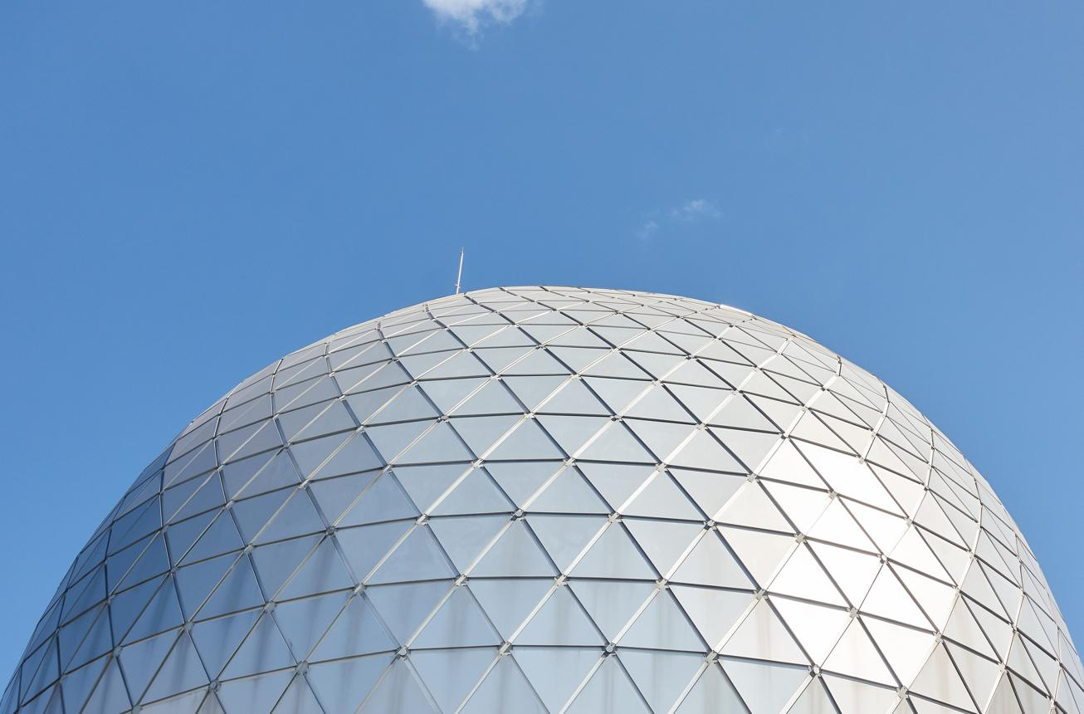
Architecture
Dome-shaped roofs and spherical architectural structures can use spherical-cap geometry.
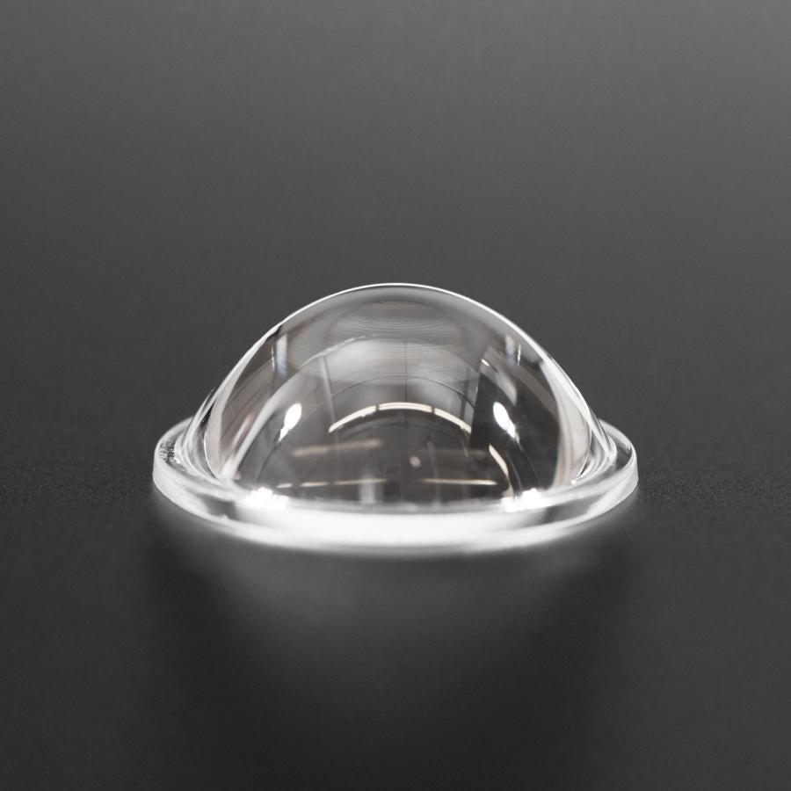
Optics and Engineering
Spherical surfaces appear in lens design, optical components, and rounded engineered parts.
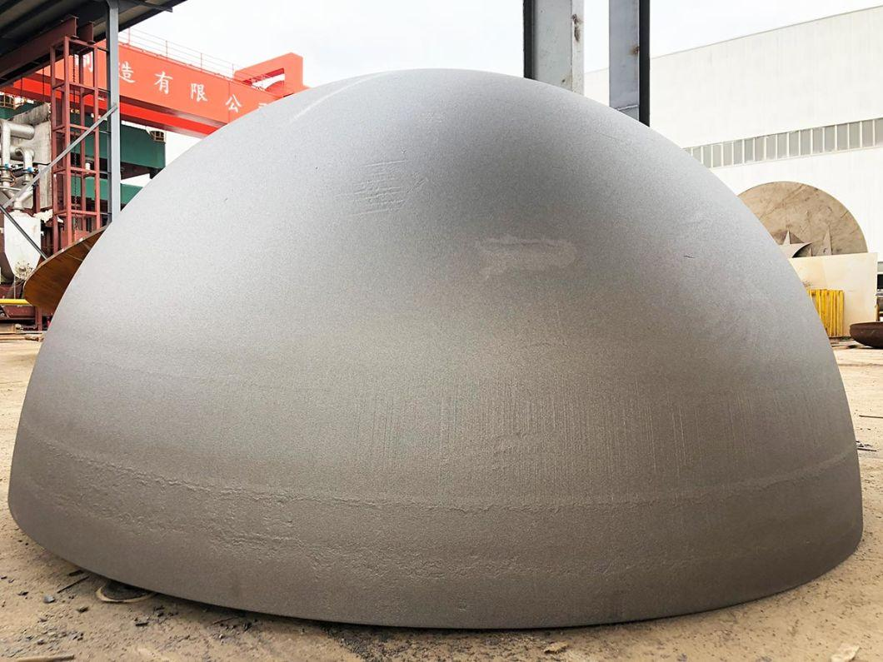
Containers and Manufacturing
Cap formulas help estimate material area and the volume of rounded portions of tanks or manufactured objects.

Key Points
# Source: AI Source: Provided by: [Data Path: Persons Table -> ID Column: 1, Name_En Column: Motasem Essam] -> From: [ChatGPT] on [7/25/2026]
- A spherical cap is part of a solid sphere cut by a plane.
- Its base is a circle.
- Its height is measured perpendicular to the base plane.
- Its base radius is $a=\sqrt{2Rh-h^{2}}$.
- Its curved surface area is $2πRh$.
- Its volume is $\frac{πh^{2}}{3}\left(3R-h\right)$.
- A hemisphere is a special case where $h=R$.
- Total surface area includes the flat circular base; curved surface area does not.

Conclusion
# Source: AI Source: Provided by: [Data Path: Persons Table -> ID Column: 1, Name_En Column: Motasem Essam] -> From: [ChatGPT] on [7/25/2026]
A spherical cap is a dome-shaped portion of a sphere bounded by a circular base and a curved spherical surface. Its geometry is determined by the radius of the original sphere and the height of the cap. These measurements allow us to calculate the base radius, curved surface area, total surface area, and volume. A hemisphere is the special case in which the cap height equals the sphere radius.

